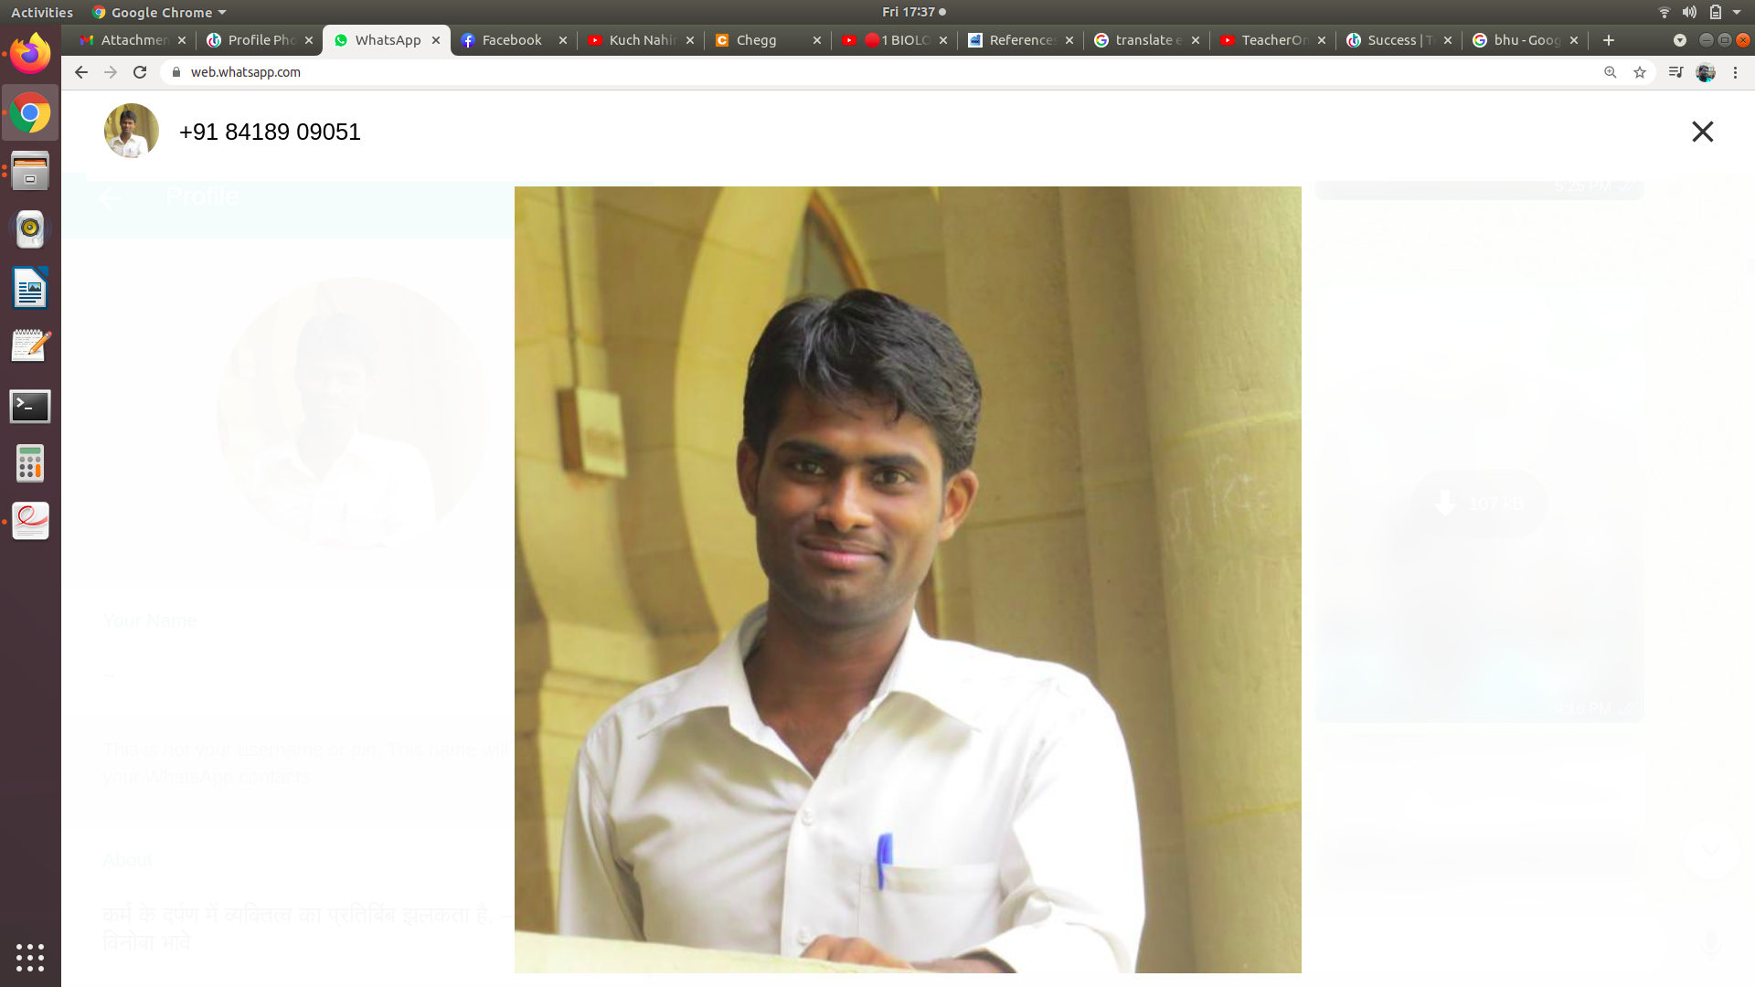**Updated Faculty E-Profile**

1. Name: **Amrit Kumar Gupta**

1. Designation and Department: **Assistant Professor, Physics**
2. Email: **amritraj7844@gmail.com**
3. Mobile No.:
4. Academic Profile: **M.Sc.**, **CSIR-NET**, **GATE**, **Ph.D.**(Pursuing)
5. Orientation:
6. Refresher:
7. Workshop/FDP Attended: **08**
8. Papers presented: **01**
9. Papers published: **04**
10. Books Published:

(Title +ISBN+ Year of Publication +Publisher)

1. Ph.D.(s) Supervised / Working:

(Name of Candidate + Topic +Year of Award)

1. Research Project (Completed / Ongoing): **01**
2. Honours / Awards:

(i) Best Student Award (**Rajvallabh Samman**) By college

(ii) **Inspire,** Awarded by The Department of Science and Technology

(**DST**), Govrement of India

1. Membership of Academic Bodies:
2. Fellowships of Academic Bodies:
3. Member BOS / RDC /Academic Council:
4. Any Other Achievement:

Date: Signature

Note:

1. Kindly submit the e-profile to [**website.jvc@gmail.com**](mailto:website.jvc@gmail.com)at the earliest.