**Updated Faculty E-Profile**

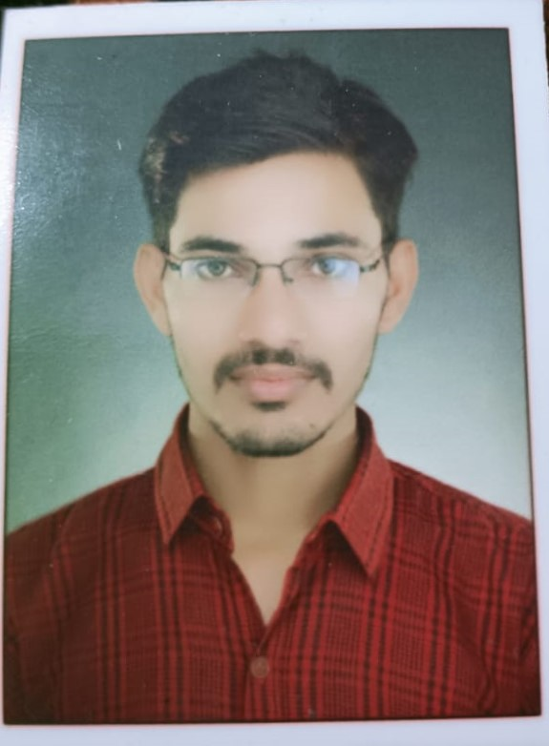

|  |
| --- |
| Recent passport size colour photograph |

1. Name: Puneet Gautam

1. Designation and Department: Assistant Professor, Department of Geography, Janta Vedic Degree College, Baraut, Baghpat(U.P.)
2. Email: gautampuneet1997@gmail.com
3. Mobile No. 7611806259
4. Academic Profile (Ph.D., NET/SLET): B.A. 2016 Government College, Karauli(University of kota, kota), M.A. 2018 University of Rajasthan, Jaipur, Rajasthan.
5. Orientation:
6. Refresher:
7. Workshop/FDP Attended: A) Workshop on Social Protection and Livelihood Security (7-11 January 2020).
8. Papers presented:
9. Papers published: A) बूंदी जिले की नैनवा तहसील में जल स्तर : स्थानिक कालिक

अध्ययन (2015-2020),ISSN-2455-5967,Ascent International Journal for Research Analysis, published in 2021

B) ISSUES AND CHALLENGES OF SCHOOL EDUCATION: AN INDIAN SCENARIO,ISSN-2455-2445, Journal of Global Resources, published in 2022

1. Books Published:

(Title +ISBN+ Year of Publication +Publisher)

1. Ph.D.(s) Supervised / Working: Ph.D. Working since May 2019 in Mohan lal Sukhadia University,Udaipur(Raj.) India.( Research Topic-Availability and Quality of Groundwater for Irrigation and Drinking Purpose A Case Study of Nainwa Tehsil of Bundi District, Rajasthan Research Supervisor-Dr. Devendra Singh Chouhan, Department of Geography, Mohan lal Sukhadia University,Udaipur, Rajasthan, India.)

(Name of Candidate + Topic +Year of Award)

1. Research Project (Completed / Ongoing):
2. Honours / Awards: Silver Medal in Senior Secondary Exam-2013
3. Membership of Academic Bodies:
4. Fellowships of Academic Bodies: UGC- NET- JRF SRF
5. Member BOS / RDC /Academic Council:
6. Any Other Achievement:A) Remote Sensing and GIS Certificate Programme (August to November 2019).

B) Online Conference on “Geographical Perspectives of Water Resources : Issues and Challenges”(16 july 2020).

C) IGU India International Conference,2020 (18-20 December 2020).

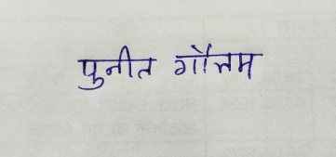

Date: 10.08.2022 Signature

Note:

1. Kindly submit the e-profile to [**website.jvc@gmail.com**](mailto:website.jvc@gmail.com)at the earliest.