**Updated Faculty E-Profile**

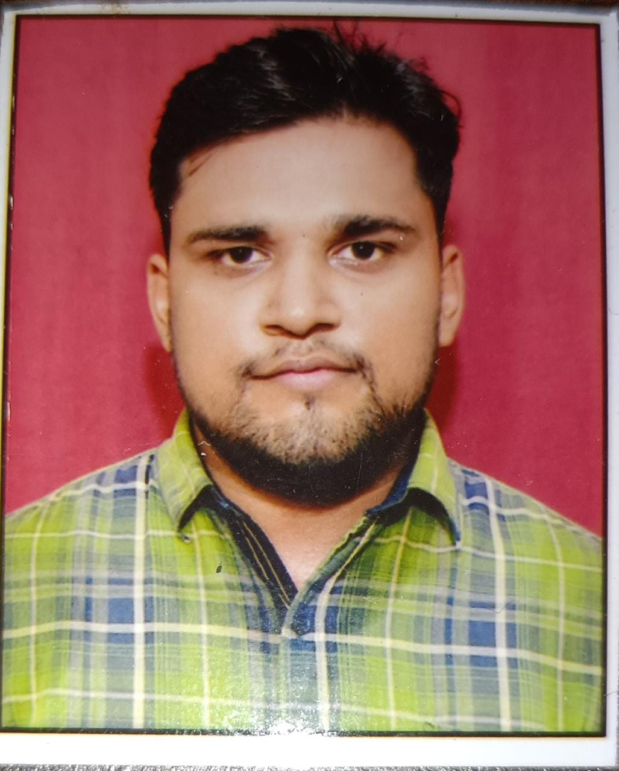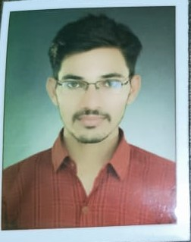

|  |
| --- |
| Recent passport size colour photograph |

1. Name: Madhur Yadav
2. Designation and Department: Assistant Professor, Department of Geography, Janta Vedic Degree College, Baraut, Baghpat (U.P.)
3. Email: madhuryadav908@gmail.com
4. Mobile No. 7394923653
5. Academic Profile (Ph.D., NET/SLET): B.A. 2015, M.A. 2017 University Of Allahabad Prayagraj U.P India.
6. Orientation
7. Refresher:
8. Workshop/FDP Attended: 2
9. Integrated Workshop on Publication Ethics and Patenting, Department of Energy and Environment BSBRACU, Lucknow, 10 feb 2020 U.P. India
10. Two Days Online National Workshop on Mentoring for Education Abroad: What You Can Do? , Panimalar Engineering College Affilated to Anna University Chennai, 21-22 May 2020 Tamilnadu, India
11. Papers presented: 1

Relationship Between Population Growth and Agriculture Pattern : A case Study of district Hamirpur (U.P.) ISBN- 978-93-87922-89-1 Year 2020, Population Explosion Food Security and Sustainable Development

1. Papers published: 2

(A) Hamirpur Janapad (U.P.) me jansankhya Vradhi Evam Vitaran Pratirup ISSN 2454-2687 Year Oct- Dec 2020 , International Journal of Reviews and Research in Social Sciences (IJRRSS)

B) Jansnkhya Visphot ( Vradhi ) Janit Samasyanye Evam Paryavaran Niyojan: Hamirpur Janpad (Uttar Pradesh) Ka Ek Pratik Adhyayan ISSN- 0022-1945 Year 2021, Journal of Interdisciplinary Cycle Research (JICR)

1. Books Published:

(Title +ISBN+ Year of Publication +Publisher)

1. Ph.D.(s) Supervised / Working: Ph.D. Working ( May 2019) in Bundelkhand University, Jhansi, U.P. India ( Research Topic : Environmental Impact of Population in District Hamirpur (U.P.) : A Geographical Study Research Supervisor : Dr. R.G. Kushwaha, Department of Geography, Atarra P. G. College, Banda, B.U. Jhansi, U.P. India )
2. Research Project (Completed / Ongoing):
3. Honours / Awards:
4. Membership of Academic Bodies:
5. Fellowships of Academic Bodies: UGC – NET- JRF SRF
6. Member BOS / RDC /Academic Council:
7. Any Other Achievement:



Date: 07/08/2022 Signature

Note:

1. Kindly submit the e-profile to [**website.jvc@gmail.com**](mailto:website.jvc@gmail.com) at the earliest.