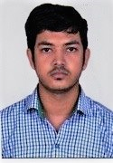**Updated Faculty E-Profile**

1. Name: **Amit Kumar**

1. Designation and Department: **Assistant Professor, Physics**
2. Email: **amitkumar727254@gmail.com**
3. Mobile No.:
4. Academic Profile: **M.Sc.**, **CSIR-NET**, **GATE**
5. Orientation:
6. Refresher:
7. Workshop/FDP Attended:
8. Papers presented:
9. Papers published:
10. Books Published:

(Title +ISBN+ Year of Publication +Publisher)

1. Ph.D.(s) Supervised / Working:

(Name of Candidate + Topic +Year of Award)

1. Research Project (Completed / Ongoing):
2. Honours / Awards:

1. Membership of Academic Bodies:
2. Fellowships of Academic Bodies:
3. Member BOS / RDC /Academic Council:
4. Any Other Achievement:

Date: Signature

Note: 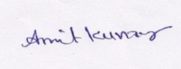

1. Kindly submit the e-profile to [**website.jvc@gmail.com**](mailto:website.jvc@gmail.com)at the earliest.